MATHEMATICS APPLICATIONS

MAWA Semester 1 (Unit 3) Examination 2016

Calculator-Assumed

Marking Key

Section Two: Calculator-assumed (100 Marks)

Question 7 (a)
Solution

Marking key/mathematical behaviours | Marks
- allocates total fat to horizontal axis  - labels both axes with correct variables  - scales both axes accurately  - selects correct type of graph  - plots any 5 points correctly  - plots remaining 4 points correctly | 1  1  1  1  1  1

Question 7 (b)
Solution

(i) Total carbohydrate = -0.849 x total fat + 82.048
(ii) r = -0.77
Marking key/mathematical behaviours | Marks
- determines gradient and intercept on vertical axis for regression line  - identifies variables in regression line  - determines correlation coefficient | 1  1  1

Question 7 (c)
Solution

Total carbohydrate = -0.849 x total fat + 82.048 = -0.849 x 30 + 83.048 = 57.6 g per 100 g
Marking key/mathematical behaviours | Marks
- substitutes correctly into equation of line from (b)  - determines total carbohydrate | 1  1

Question 7 (d)
Solution

Prediction is fairly reliable. It is made from within the data set – ie interpolated AND the correlation coefficient is much nearer -1 than 0
Marking key/mathematical behaviours | Marks
- identifies strength of the prediction  - gives one reason to justify prediction  - gives second reason to justify prediction | 1  1  1

Question 8 (a)
Solution

7%
Marking key/mathematical behaviours | Marks
- states the correct percentage | 1

Question 8 (b)
Solution

Year | 2012 | 2013 | 2014 | 2015 | 2017 | 2018
Number of tigers | 427 | 457 | 489 | 523 | 599 | 641

Marking key/mathematical behaviours | Marks
- determines correct year for population of 641  - determines another two entries  - determines another two entries | 1  1  1

Question 8 (c) (i)
Solution

$$P=427×{1.07}^{(n-1)}$$
Marking key/mathematical behaviours | Marks
- expresses rule in correct format with correct starting term  - uses correct factor of ${1.07}^{(n-1)}$ in rule | 1  1

Question 8 (c) (ii)
Solution

$P=427×{(1.07)}^{8}$
=686
Marking key/mathematical behaviours | Marks
- identifies correct term  - determines correct population | 1  1

Question 8 (d)
Solution

No because the difference between the annual populations is not constant
Marking key/mathematical behaviours | Marks
- concludes correctly  - justifies conclusion | 1  1

Question 8 (e)
Solution

For 2022, n =11
$P_{11}=427×{(1.07)}^{10}$= 839
Marking key/mathematical behaviours | Marks
- identifies correct term n = 11  - determines population | 1  1

Question 8 (f)
Solution

$$P_{? }>=1000$$
? = 14
2025
Marking key/mathematical behaviours | Marks
- identifies procedure to solve problem  - determines correct year | 1  1

Question 8 (g)
Solution

The population will reach the target before 2025 (earlier)
There is an increase in the rate of growth
Marking key/mathematical behaviours | Marks
- identifies earlier time  - describes faster growth | 1  1

Question 9 (a)
Solution

EFGB (23), EFDGB (21), EACB (20)
Quickest route is E A C B. Time taken is 20 minutes.
Marking key/mathematical behaviours | Marks
- identifies edges for quickest route  - determines time taken  - shows a method for solution | 1  1  1

Question 9 (b)
Solution

Jane’s route: via F is E F D G B
Marking key/mathematical behaviours | Marks
- identifies initial edge and finishing point  - identifies edges for quickest route from F to B | 1  1

Question 9 (c)
Solution

Time taken via F = 21 minutes walking + 5 minutes at florist = 26 minutes.

26 mins – 20 mins = 6 minutes. Jane’s journey took 6 minutes longer.
Marking key/mathematical behaviours | Marks
- determines time taken via F  - determines difference in times | 1  1

Question 9 (d)
Solution

EFDGBCA Visiting every intersection to check traffic lights working.
Marking key/mathematical behaviours | Marks
- identifies Hamiltonian path  - identifies practical use of Hamiltonian path | 1  1

Question 10 (a)
Solution

Survey more people OR Survey a greater variety of people
Marking key/mathematical behaviours | Marks
- suggests improvement for data collection | 1

Question 10 (b)
Solution

How many hours did you spend driving a car before you sat the Practical Driving Assessment?
Marking key/mathematical behaviours | Marks
- determines an appropriate survey question | 1

Question 10 (c)
Solution

Collect data to the nearest hour
Collect data from more people
Get the students to keep a driving log
Collect data from a greater range of students
Marking key/mathematical behaviours | Marks
- identifies two ways to improve the data collection | 2

Question 10 (d)
Solution

The mode is 30 and so is the median. Thirty hours is a typical time for these students to spend on driving before sitting the PDA.
The maximum score was 50, this is the most number of hours any student spent driving before the PDA.
The minimum number of hours of driving before the PDA was 25 – it is the lowest score.
Marking key/mathematical behaviours | Marks
- interprets the frequency table provided, drawing conclusions and uses data to justify these conclusions. | 2  2

Question 11 (a)
Solution

Falling at 1.5% per year
Marking key/mathematical behaviours | Marks
- identifies rate of decline | 1

Question 11 (b)
Solution

The population change is classified as exponential decay.
Marking key/mathematical behaviours | Marks
- identifies decay or negative change  - identifies the change is exponential | 1  1

Question 11 (c)
Solution

242 000
Marking key/mathematical behaviours | Marks
- identifies first term | 1

Question 11 (d)
Solution

The 7th term is 242 x 0.985 ⁶ = 221 020
Marking key/mathematical behaviours | Marks
- determines 7th term | 1

Question 11 (e)
Solution

June 30, 2028
Marking key/mathematical behaviours | Marks
- identifies recording at the end of June  - determines correct year | 1  1

Question 11 (f)
Solution

Date | No pigs imported | 5000 pigs imported each year after 2015
30 Jun 2015 | 242 000 | 242 000
30 Jun 2016 | 238 370 | 243 370
30 Jun 2017 | 234 794 | 244 719
Linear recurrence relation | P₀ = 242 000  P_{n+1} = 0.985 P_{n} | P₀ = 242 000  P_{n+1} = 0.985 P_{n} + 5

Marking key/mathematical behaviours | Marks
- enters number of pigs for first option  - enters number of pigs for second option  - identifies linear recurrence relation for first option  - identifies linear recurrence relation for second option | 1  1  1  1

Question 12 (a)
Solution

A = 100 – 4 – 21.1 – 47.9 = 27 or 27%
Marking key/mathematical behaviours | Marks
- determines remaining percentage | 1

Question 12 (b)
Solution

Data have been rounded
Marking key/mathematical behaviours | Marks
- identifies cause of incorrect total | 1

Question 12 (c)
Solution

Shopping
Marking key/mathematical behaviours | Marks
- interprets data in table | 1

Question 12 (d)
Solution

games
Marking key/mathematical behaviours | Marks
- interprets data in table | 1

Question 12 (e)
Solution

A higher proportion of the males surveyed never use the internet for email i.e 31.6% males compared to 20.5% of the females. A higher proportion of females use the internet for email often i.e. 13.6% of females compared to 9.5% of the males.
Marking key/mathematical behaviours | Marks
- provides an accurate statement of proportion and provides data to support the statement  - provides a second accurate statement of proportion and provides data to support the statement. | 1  1

Question 12 (f)
Solution

There could have been more males in the survey and 90% of this number may have been greater than the 92.5%.
The respondents were left to interpret the descriptors of rarely, sometimes and often so there is no indication in the data about the number of times respondents used the internet.
Marking key/mathematical behaviours | Marks
- gives one reason to support the conclusion provided  - gives a second reason to support the conclusion provided | 1  1

Question 12 (g)
Solution

NOT SUPPORTED
The survey did not collect data about the amount of time, only the proportion of users so it is not known how much time people spent on the internet.
Marking key/mathematical behaviours | Marks
- selects correct option  - recognises the limitation of the data | 1  1

Question 13 (a)
Solution

$1800
Marking key/mathematical behaviours | Marks
- reads scatter plot | 1

Question 13 (b)
Solution

Cost of flight
Marking key/mathematical behaviours | Marks
- identifies response variable | 1

Question 13 (c) & (h)
Solution

Marking key/mathematical behaviours | Marks
- (c) identifies data point – circled  - (d) plots data point – red dot | 1  1

Question 13 (d)
Solution

95.4%
Marking key/mathematical behaviours | Marks
- identifies coefficient of determination | 1

Question 13 (e)
Solution

r = 0.9766
Marking key/mathematical behaviours | Marks
- calculates correlation coefficient | 1

Question 13 (f)
Solution

0.98
It was 0.9538 after the outlier was removed and would have been higher prior to that.
Marking key/mathematical behaviours | Marks
- identifies correct value for coefficient of determination  - justifies choice | 1  1

Question 13 (g)
Solution

Cost = 0.103 x 10000 – 7.166 = $1023
Marking key/mathematical behaviours | Marks
- shows substitution into the equation provided  - determines predicted cost | 1  1

Question 13 (i)
Solution

The prediction is very reliable
The correlation coefficient is very close to 1 (0.9766)
Marking key/mathematical behaviours | Marks
- describes prediction  - justifies conclusion | 1  1

Question 14 (a)
Solution

The values are all zero because players do not compete against themselves
Marking key/mathematical behaviours | Marks
- explains the values in the leading diagonal | 1

Question 14 (b)
Solution

Total number of games won by each player
Marking key/mathematical behaviours | Marks
- identifies total number of games  - describes games belonging to one player | 1  1

Question 14 (c)
Solution

The person in row m had lost to the person in column n
The person in row n must have beaten the person in column m. It is the same match so the opposite results are stored in the “complementary” positions..
Marking key/mathematical behaviours | Marks
- identifies the same match is described  - identifies opposite results for the opponents | 1  1

Question 14 (d)
Solution
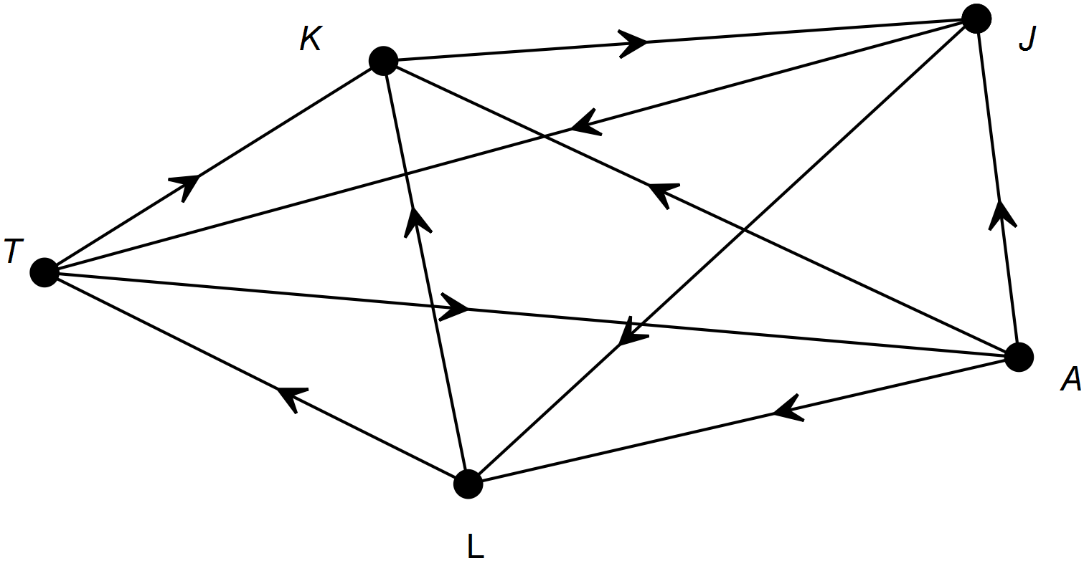

Marking key/mathematical behaviours | Marks
- draws a complete graph  - identifies 7 correct edges  - identifies remaining 2 correct edges | 1  1  1

Question 14 (e)
Solution

(i) Kate and Andrew
(ii) row 1 column 3
Marking key/mathematical behaviours | Marks
- interprets digraph  - relates digraph to matrix | 1  1

Question 14 (f)
Solution

0, There was no one that Jane beat who also beat Liz
Marking key/mathematical behaviours | Marks
- locates element in matrix  - interprets matrix | 1  1

Question 14 (g)
Solution

3
Marking key/mathematical behaviours | Marks
- uses adjacency matrix to solve problem | 1

Question 15
Solution

Sequence | Arithmetic or geometric | Exponential or linear | Growth or decay
A | arithmetic | linear | growth
B | geometric | exponential | decay
C | geometric | exponential | decay
D | arithmetic | linear | growth
E | arithmetic | linear | growth
F | geometric | exponential | decay

Marking key/mathematical behaviours | Marks
- Identifies of given sequence | 6

Question 16 (a)
Solution

It decreases
Marking key/mathematical behaviours | Marks
- interprets relationship between variables | 1

Question 16 (b)
Solution

(i) relationship is negative
(ii) relationship is linear
(ii) relationship is strong
Marking key/mathematical behaviours | Marks
- interprets negativity of relationship  - interprets linearity of relationship  - interprets strength of relationship | 1  1  1

Question 16 (c)
Solution

Generally speaking students did ATAR or VET in 2015 so the percentages added up to about 100%. Some students achieved both (over 100% in some schools) and some achieved neither (less than 100%). One variable does not cause the other but there is a very strong association between them because students do not tend to choose to do both as the time to do both is limited.
Marking key/mathematical behaviours | Marks
- indicates variables are complementary  - describes lack of causality | 1  1

